In web browser, log in to http admin console of your IBM i (URL to be provided as below)

<IPaddress>:2001/HTTPAdmin

Click on Create HTTP server

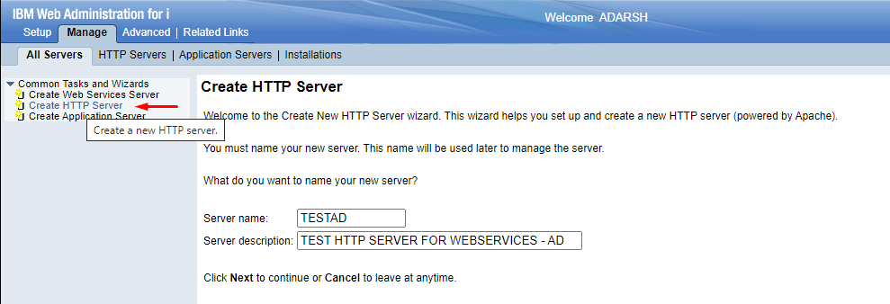

Specify an available port during setup, say 8090.

Click on display config file to check its’ contents:

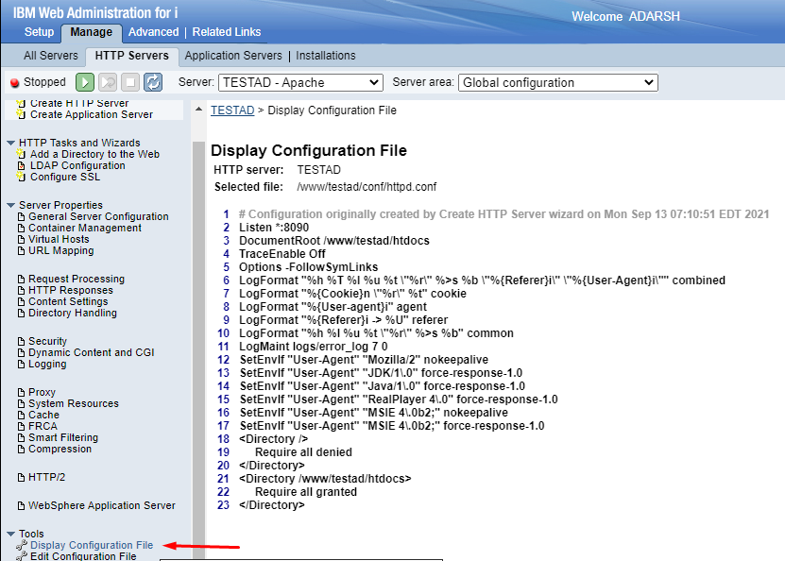

--------------------------------------------------------------------------------------------------------

In order to run program when URL is called, do below steps:

Edit config file:

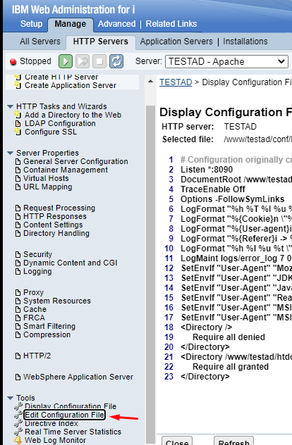

Add the below line at the end,

ScriptAliasMatch /dfs/([a-z0-9]+) /Qsys.lib/adarsh.lib/$1.pgm

<Directory /Qsys.lib/adarsh.lib>

Require all granted

</Directory>

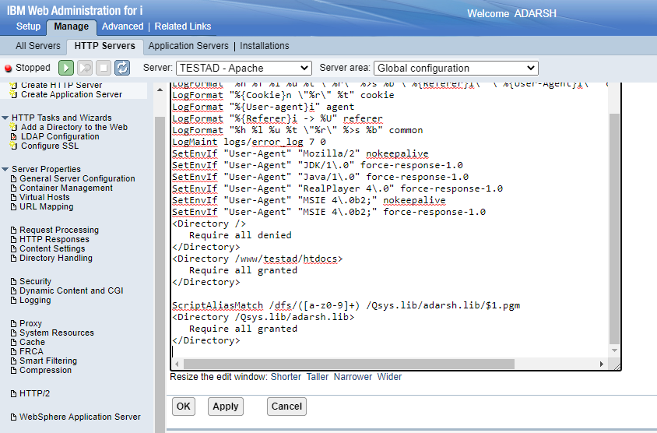

Now the http call could be: <ipaddress>:8090/dfs/<pgmName>

The <pgmname> specified should be under lib qsys > Adarsh

When requests are specific, the URL could be <ipaddress>:8090/dfs/<pgmName>/<pgmParameter>

If request is to be made by http Auth, add the below in http config file:

SetEnvIf Authorization "(.*)" HTTP_AUTHORIZATION=$1

In IBM i, create a test pf

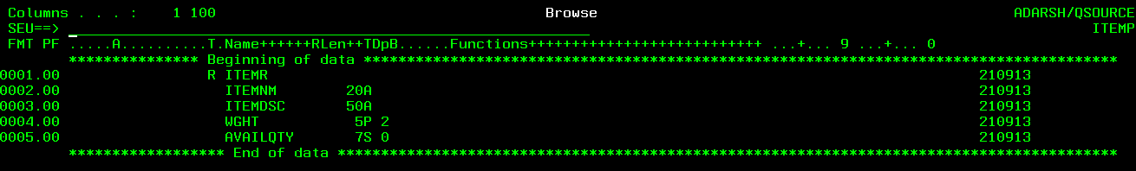

And the program to support WebServ methods to this file could be ITEMS.